Email Subject: Replacement_Order Number_Product Nunber

Email: xxx@xxx
Name: xxxx
Address:xxxx
CITY: xxxx
STATE: xxxx
Country: xxxx
Zip code: xxxx
Contact Number: xxxx

- Why do you need a replacement?
It was lost when I opened the package
I broke it while assembling
Other reasons

- Where did you buy(Please fill in the website address or platform name)?
xxxx

- Order Number: xxxx

- Product Name/Number: xxxx

- First page of Instructions (Because the product has been updated many times, we need to confirm the version.): The following pictures are sample pictures, please replace with your own pictures
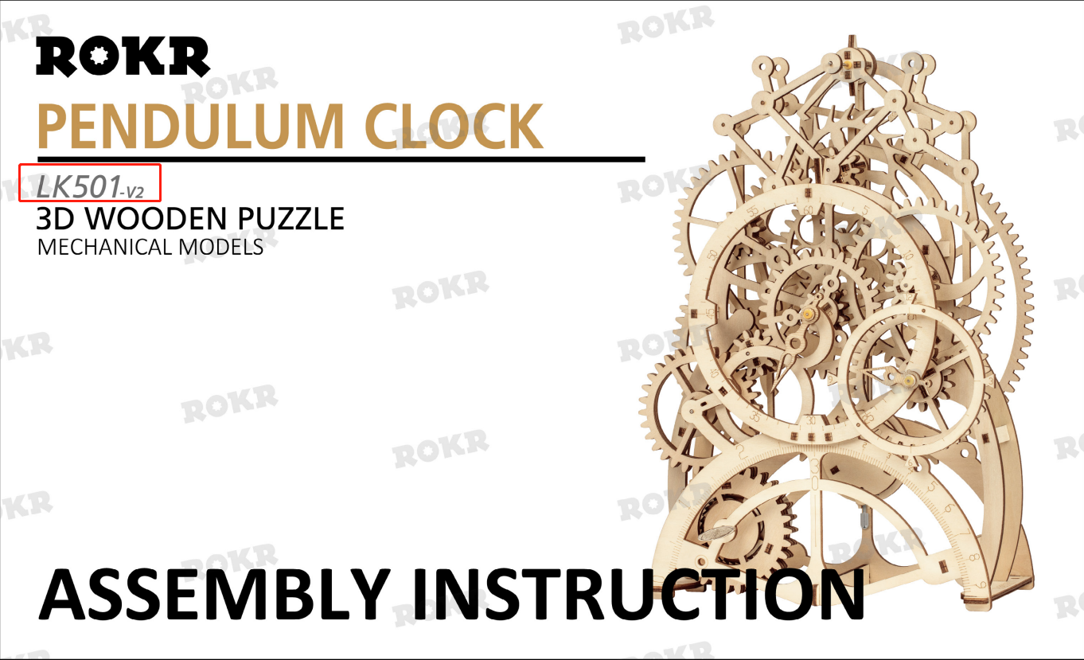
- Replacement Part code and quantity(e.g. A1*1+B2*3):xxx*x+xxx*x

- Image of replacement part(To ensure that the parts we send are correct, please circle the parts in the Instructions) :The following pictures are sample pictures, please replace with your own pictures
